Apple 2017 Review

iPhone 7 Review

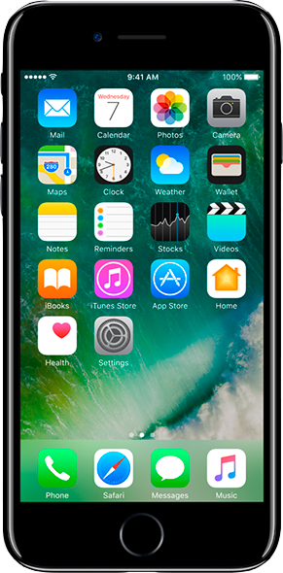The iPhone 7 and 7 Plus are deeply unusual devices. They are full of aggressive breaks from convention while wrapped in cases that look almost exactly like their two direct predecessors. Even that continuity of design is a break from convention; after almost a decade of Apple’s steady two-year iPhone update pattern, merely retaining the same design for a third straight year plays against expectations.

Inside that case, everything else about the iPhone 7 is a decisive statement about the future. The dual cameras on the iPhone 7 Plus promise to usher in a new era in mobile photography. The iconic iPhone home button is no longer a physical button, but instead a sophisticated ballet of pressure sensors and haptic vibration motors that simulate the feel of a button. The new A10 Fusion processor blends two high-power cores that rival laptop performance with two low-power cores that combine with a much

larger battery to extend run time by up to two hours.

And, yes, Apple has removed the headphone jack.

Removing the headphone jack is an act of pure confidence from Apple, which is

the only company in tech that can set off a sea changes in the industry by aggressively dropping various technologies from its products. Floppy drives, optical drives, its own proprietary 30-pin iPod connector, flash, even USB — Apple decides that it’s time to move on, and it has a massive installed base of customers that love and trust the company who make it happen. And now it’s decided that — yikes — the headphone jack is over.

After using the iPhone 7 and 7 Plus for about a week, it’s clear to me that Apple has forceful, but considered opinions about how the next generation of phones should fit into our lives. But it’s also clear that the iPhone 7 is a transitional step to that vision of the future, not a complete expression of it. The question for would-be upgraders is simple: is all of the latent promise in this phone worth the inconvenience of that transition?

There’s really no getting around it: the iPhone 7 and 7 Plus look more or less exactly like the iPhone 6 and 6 Plus from 2014. They are now water resistant, which is nice, although they’re not fully waterproof — keep them submerged in a meter of water for more than 30 minutes and things might not go your way. Samsung’s Galaxy S7 and Note 7 are technically even more water resistant, but I think it’s basically a push — you can get these phones casually wet now without catastrophe, and that’s a big win. If you want to go snorkeling with your iPhone, you should probably get a case anyhow.

Apart from the water resistance, there are three main external differences between the 6 and 7: first, the antenna lines on the back have been tweaked and colored to blend into the body on the matte black and glossy jet black models, which is a welcome refinement. (The antennas remain a dull gray color on the silver, gold, and rose gold variants; Apple says there are limits on what colors can be applied.) Second, the camera bump has been enlarged and more artfully curved into the rear casing, which looks particularly handsome on the smaller phone with a single camera.

And third — here it is again — there’s no headphone jack

The best laptop you can buy

The 13-inch MacBook Air is the laptop that hits the right balance between power, portability, battery life, and comfort. It's super sleek, so it can fit in nearly any bag, is light enough that it won't

cause back issues from carrying it around all the time, and even the base model is powerful enough for the everyday tasks you might demand from a laptop (though many people would benefit from upgrading to 8GB of RAM).

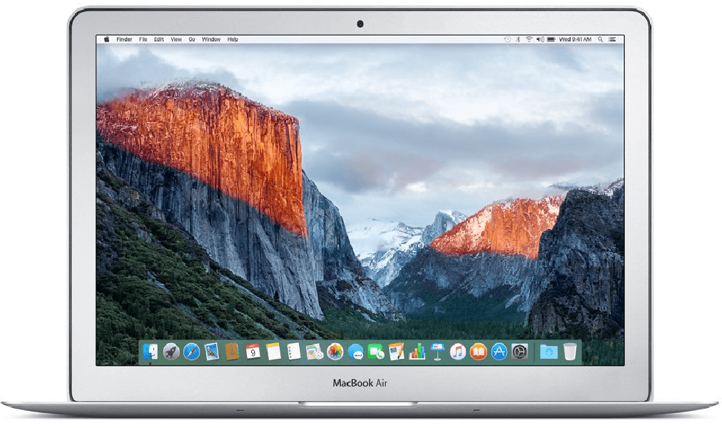None of this should really be a surprise — the MacBook Air has been the high-water mark for laptops for years and has been the choice of many professional and casual laptop users. Its screen isn't the highest resolution you can buy, but it's still bright and hits a good balance between size and usable screen real estate. Apple sells computers with better displays — the displays on the new MacBook and the MacBook Pro with Retina Display easily outclass the MacBook Air's screen — but they are either heavier, less powerful, or not as battery efficient as the Air. Deciding between the MacBook Air and the MacBook Pro is not easy. A solid case could be made either way: the Retina Display on the Pro is a compelling option, plus the Pro is slightly more powerful. But it's heavier and more expensive than the Air

A comparably equipped MacBook Pro   
in terms of RAM and SSD storage (8GB RAM, 256GB SSD) will cost $200 more than the equivalent MacBook Air. If you're investing in a computer for the long haul, for example, something you're going to use for more than four years, the Pro could be worth that extra cost, as its higher-end display makes it slightly more future-proof. But for most people, the Air just barely edges it out thanks to its lower cost, lighter weight, and better battery life.



The iPod turns 15

Fifteen years ago today, on October 23rd, 2001, Steve Jobs stood up on stage and announced the original iPod. Since that day, the iPod has changed the way people buy and listen to music, sold millions of devices, and laid the foundation for the powerhouses that Apple has had with the iPhone and iPad. And while the classic iPod design was finally retired two years ago, and the remaining members of the iPod line are less important to Apple’s strategy today than they were years ago, it’s still an integral part of history, both for the company and the larger tech industry. So here’s a look back at some highlights in the history of the king of MP3 players, from the physically scrolling plastic wheel of the original iPod to the smooth glass and aluminum of today’s iPod Touch.